TRƯỜNG ĐẠI HỌC **SƯ PHẠM KỸ THUẬT THÀNH PHỐ HỒ CHÍ MINH**

HCMC University of Technology and Education

**KHOA ĐÀO TẠO CHẤT LƯỢNG CAO**

NGÀNH CÔNG NGHỆ THÔNG TIN



**­BÁO CÁO ĐỒ ÁN:** Read Pro

Member’s group:

1/ Võ Minh Huy 18110020

2/ Bùi Quang Hồ Minh Vương 18110070

Lecture: TS. Huỳnh Xuân Phụng

**TP. HỒ CHÍ MINH, THÁNG 6**

SCORE

|  |  |  |  |
| --- | --- | --- | --- |
| CRITERIA | CONTENT | PRESENT | TOTAL |
| SCORE |  |  |  |

ASSESSMENT OF THE TEACHERS:

……………………………………………………………………………………………………………………………...

……………………………………………………………………………………………………………………………...

……………………………………………………………………………………………………………………………...

……………………………………………………………………………………………………………………………...

……………………………………………………………………………………………………………………………...

……………………………………………………………………………………………………………………………...

……………………………………………………………………………………………………………………………...

……………………………………………………………………………………………………………………………...

……………………………………………………………………………………………………………………………...

……………………………………………………………………………………………………………………………...

……………………………………………………………………………………………………………………………...

……………………………………………………………………………………………………………………………...

***Thanks***

*We would like to sincerely thank the High Quality Training Department, Ho Chi Minh City University of Technical Education for creating favorable conditions for us to study and complete this project.*

*We would like to express our deep gratitude to Huynh Xuan Phung for giving us wholehearted guidance and guidance during the implementation process.*

*We would like to thank the attention and help of friends during the implementation.*

*Although I have tried to complete the project within the scope and ability to allow but certainly inevitable shortcomings.*

*We hope to receive the sympathy, suggestions and devoted guidance of teachers and friends.*

TP.HCM, ngày 30 tháng 06 năm 2019

Nhóm sinh viên thực hiện

Võ Minh Huy-18110020

Bùi Quang Hồ Minh Vương-18110070

Table of Contents:

# Catalogue of shapes ………………………………………………

# List of tables………………………………………………………

# Chapter 1: Program Overview……………………………………

## General Introduction

## Software specification

# Chapter 2: Plan……………………………………………………

## Subdivision at work:

# Chapter 3: Software Design………………………………………

## Algorithm

## Design Class

# Chapter 4: Install and Test…………………………………………

# Chapter 5: Conclusion and Development…………………………

## Reference MaterialChapter 1 : Program Overview

1. *Genneral Introduction*

Request: Manage readable document (like Kinlde)

* Manage : Information of user (username , password, list of document, note , including admin also, …)
* Readable document : include all of document that can read like: pdf (.pdf), right now only pdf file.
* Allow user to make some note for different kinds of books seperately.
* Show roadmap of books selected by user.

Analysis : Creat database to save information and use datagridview control on winform to show data for user, use axacrobat (adobe reader) to read pdf file.

1. *Software Specfication*

* Program only allow admin to choose and save pdf file.
* Input : File Document (PDF file), image and type classification.
* Output : List of information about documents which is opened by user, admin.
* Requested by the proposed project.
* Adopt object Oriented programming and new software technologies.
* Lightweight software, stable running.
* Tool and Technology used:

Entity framework

Visual studio 2019 (.NET framework)

Microsoft SQL server management studio 18

Chapter 2 : Plan

1. *Subdivision at work*

|  |  |  |  |
| --- | --- | --- | --- |
| STT | Tên sinh viên | Desciption work | % Contribute |
| 1 | Võ Minh Huy | Design Program’s RoadMap and Note, SearchTool Design database  Test the whole program, fix some bug.  Write Report | 50% |
| 2 | Bùi Quang Hồ Minh Vương | Design Program  Annalysis Interface  Write code  Design 3 layer model  Connect to database  Design Program’s MDI, Login, Logout | 50% |

Chapter 3 : Software Design

**How to do :**

Need to solve 2 importance problem :

*First* : How to show a document on form

Solution : use OpenFileDialog to open document and get link, use adobeaxacorbat (provided by adobe reader) to read document.

*Second* : Save and change information from form to database and upload data to form.

Also: Show roadmap of book selected by user.

Solution : use SQL server 2019 to save information of user and document, use entityframework query to load data from database to form and use datagridview to show data.

**Algorithm:**

### Search book from database [Document] by typing book name using textchanged event for textbox

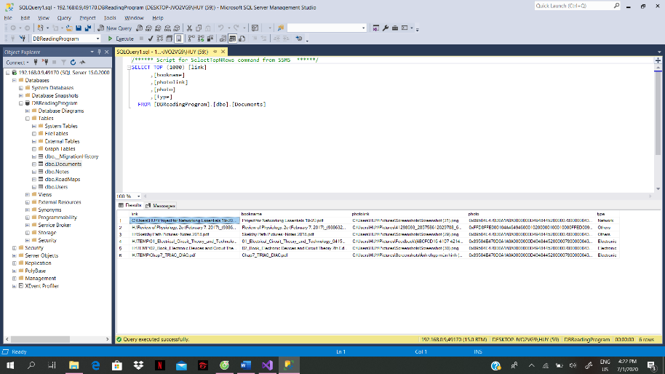

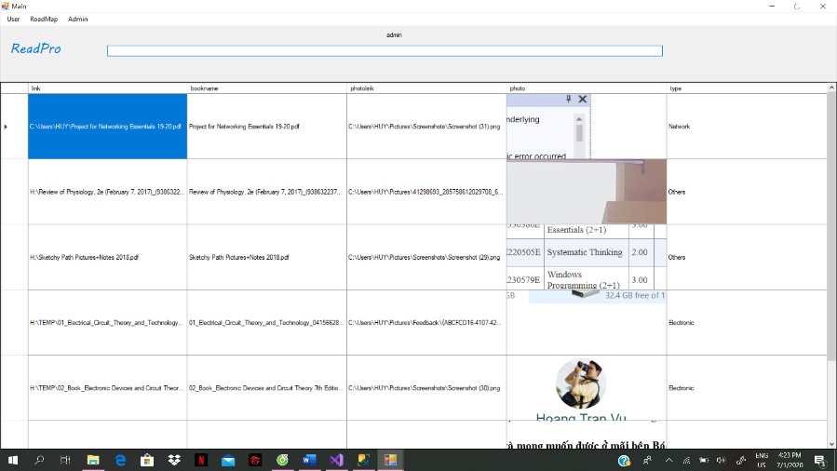

Main form to search book

### Show information of books by double clicking on datagridview ( datagrid view double click event) it will transfer to book info form and click on the image to read the book

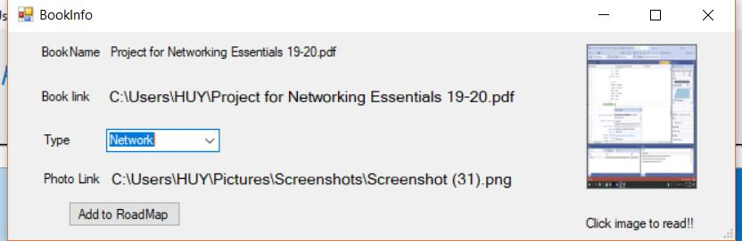

Book Information Form

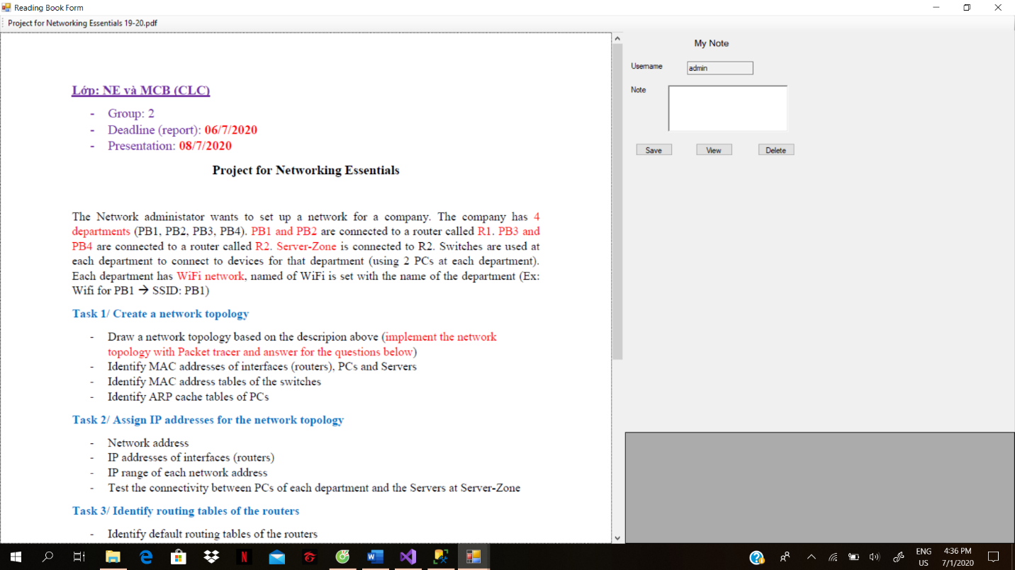

### Reading Form

### Adding book for searching (Admin ONLY)

* 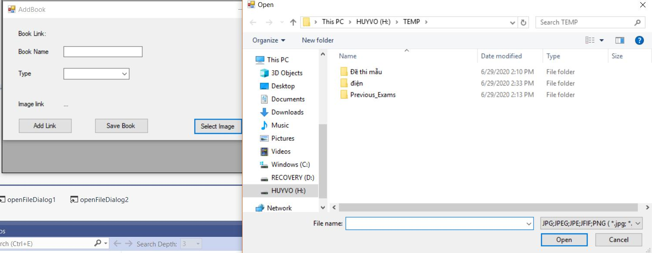Add image for the book (by pressing select image button) (openfilediaglog function)
* Add the book’s file link (openfilediaglog function)
* 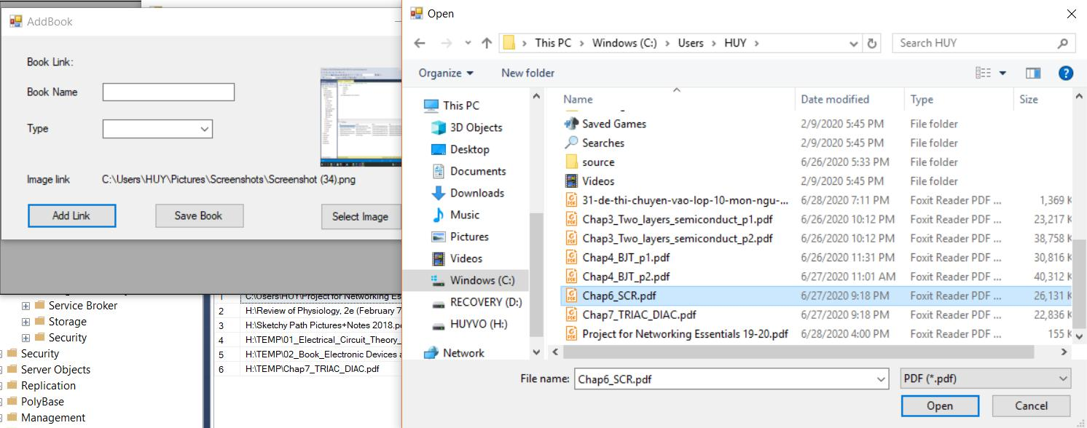Classify type of the book then press the save button, the book will be saved to [Document] database.

### Login form and Registration form (the name and password must be correct to get into the main form based on [user] database)

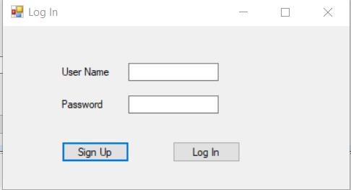

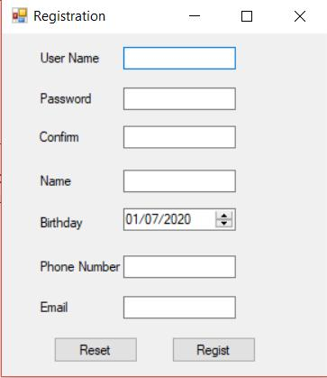

Login form

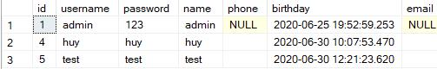

Registration form

User database table

**Design :**

|  |  |  |  |
| --- | --- | --- | --- |
| **STT** | **Name** | **Code** | **Function** |
| **1** | **Controllers** | | Load to datasource of Datagridview |
|  | BookController |  | Some basic function on book like add new book, check existeance of book, convert image to binary form. |
|  | RoadMapController |  | Some basic function on roadmap like remove book out of roadmap, get all information of book selected by user in roadmap. |
|  | UserController |  | Some basic function on user like delete existing user, getexistusername to login, check existing username while registering, add new user, get list of all user, change pass. |
| **2** | **Models** |  | Show information of each component in this project |
|  | ConnectDB | class ConnectDB  {  public ConnectDB()  {  SqlConnection con = new SqlConnection(@"Data Source=localhost\SQLEXPRESS;Initial Catalog=DBReadingProgram;Integrated Security=True");  }  public SqlConnection getcon()  {  return new SqlConnection(@"Data Source= localhost\SQLEXPRESS;Initial Catalog=DBReadingProgram;Integrated Security=True");  }  } | Connect database to get data |
|  | Documents | public partial class Document  {  public string link { get; set; }  public string bookname { get; set; }  public string photolink { get; set; }  public byte[] photo { get; set; }  public string type { get; set; }  } | Basic information of a document |
|  | Users | public partial class User  {  public int id { get; set; }  public string username { get; set; }  public string password { get; set; }  public string name { get; set; }  public string phone { get; set; }  public Nullable<System.DateTime> birthday { get; set; }  public string email { get; set; }  } | Basic information of a user |
|  | Note | public partial class Note  {  public int id { get; set; }  public string bookname { get; set; }  public string username { get; set; }  public string note1 { get; set; }  } | Basic information of a note |
|  | RoadMap | public partial class RoadMap  {  public string rmid { get; set; }  public string link { get; set; }  public string username { get; set; }  public string bookname { get; set; }  public string photolink { get; set; }  public byte[] photo { get; set; }  public string type { get; set; }  } | Basic information of a roadmap |
| 3 | **Views** | | |
|  | frmLogIn |  | To Allow people use program |
|  | Main |  | Mainform allow user to search book, mdi form with user, roadmap to allow user to change some information of themselves and roadmap |
|  | BookInfo |  | Show info of a book and allow user to add to their own roadmap. |
|  | ReadForm |  | User can read book in this form and make some note on it. Each book has its unique note made by different users. |
|  | AllUser |  | (admin only) show all information of user and admin is allowed to delete any user as wanted. |
|  | AddBook |  | (admin only) add new book by selecting image and book link, classify type of book then press the save button to store it to database. |
|  | frmPassChange |  | Allow user to change pass |
|  | frmRegistration |  | Register new account |
|  | RoadMap |  | Show all books selected by user, each user has their unique roadmap. |
|  | UpdateInfo |  | Update info of user |

**Method:**

|  |  |  |  |
| --- | --- | --- | --- |
| STT | Name | Code | Function |
| 1 | addBook | Input : Document class  Output : The Document was added to list of document. | This method used to add new document to Documents table in database |
| 2 | checkExistBook | Input : Book Link  Output : The Document was checked its existence. | This method used to prevent duplicate books. |
| 3 | Converttobinary | Input: string photo link  Output: The file link was converted to binary form in order to save it to Document table. | This method converted photo link to binary form and make its allowance to store in database. |
| 4 | DeletefromRM | Input: string book name to delete.  Output: The information of book in roadmap has been deleted. | This method allow user to delete some books out of their own roadmap. |
| 5 | GetRoadMap | Input:  Output: Show all book’s information of user owned roadmap. | This method allow user to reveal their own roadmap. |
| 6 | DeleteUser | Input: string user name  Output: User has been deleted | This method only allow admin to delete any user as wanted. |
| 7 | getExistUsername | Input: string user name  Output: Get the name of user from database | This method works with login form as it retrieve data from [User] table and decide it user can login or not base on appropriate account. |
| 8 | checkExistUsername | Input: string user name  Output: Check from the [User] table. | This method checks for username to avoid duplicate account. |
| 9 | addUser | Input: user class  Output: New user added to [User] table. | This method allow to create new user account. |
| 10 | GetallUsers | Input:  Output: Show all information of User. | This method only admin to reveal all information of user. |
| 11 | updateUser | Input: User class  Output: updated information of user | This method allow admin to change some basic informations of user. |
| 12 | Changepass | Input: User class, string pass.  Output: Password changed | This method allow user to change their password account. |

**Design Database:**

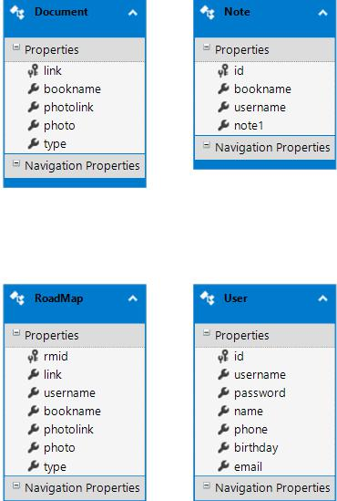

|  |  |  |
| --- | --- | --- |
| **TT** | **Name of Table** | **Purpose** |
| 1 | Document | Save information of book file which is opened by user |
| 2 | User | Save username , password of user. |
| 3 | Note | Save information of note made by users |
| 4 | RoadMaps | Save roadmap of different users. |

|  |  |  |  |
| --- | --- | --- | --- |
| **TT** | **Field** | **Type** | **Purpose** |
| 1 | Link | Nvarchar(128) | Store link of document |
| 2 | bookname | Nvarchar(MAX) | Store name of document |
| 3 | photolink | Nvarchar(MAX) | Store photo link |
| 4 | photo | Varbinary(MAX) | Store image file |
| 5 | type | Nvarchar(MAX) | Store type of document |

Document table :

|  |  |  |  |
| --- | --- | --- | --- |
| **TT** | **Field** | **Type** | **Purpose** |
| 1 | id | int | Store id of each user |
| 2 | username | Nvarchar(MAX) | Store username of user to login |
| 3 | password | Nvarchar(MAX) | Store Password of user to login |
| 4 | name | Nvarchar(MAX) | Name of user after login in the main form. |
| 5 | phone | Nvarchar(MAX) | Store phone of each user |
| 6 | birthday | datetime | Store birthday of each user |
| 7 | email | Nvarchar(MAX) | Store email of each user |

User table:

Note table:

|  |  |  |  |
| --- | --- | --- | --- |
| **TT** | **Field** | **Type** | **Purpose** |
| 1 | id | int | Store id of each note |
| 2 | bookname | Nvarchar(MAX) | Store name of the book that user has made note on it |
| 3 | username | Nvarchar(MAX) | Store name of user made that note |
| 4 | note | Nvarchar(MAX) | Store the content of the note |

RoadMaps table:

|  |  |  |  |
| --- | --- | --- | --- |
| **TT** | **Field** | **Type** | **Purpose** |
| 1 | rmid | Nvarchar(128) | Store id of each roadmap |
| 2 | link | Nvarchar(MAX) | Store link of the document |
| 3 | username | Nvarchar(MAX) | Store name of the user |
| 4 | bookname | Nvarchar(MAX) | Store name of the document |
| 5 | photolink | Nvarchar(MAX) | Store photo link |
| 6 | photo | Varbinary(MAX) | Store photo file |
| 7 | type | Nvarchar(MAX) | Store type of document |

**Design Interface:**

*Form LOGIN and Sign-up:*

**

**

|  |  |  |
| --- | --- | --- |
| *Form Read Document and making note:* | To read document | Võ Minh Huy  To read pdf file, I used tool provided by adobe reader. Also user are allowed to make an many notes as they want and view what they have noted by pressing view button. They can also delete any note by double cliking on it and press delete button. Each book has its own notes made by a variety of users. |
| *Main Form:* | To show list of document added by admin and search it by typing book’s name. | Bùi Quang Hồ Minh Vương  List of document need a large region to show all the information so using datagridview is a great solution. Main gui, user can choose different task like log out, change their information, show their own roadmap, and only admin have the ability to see list of user and add new book to list. |

Chapter 4 : Install and Test

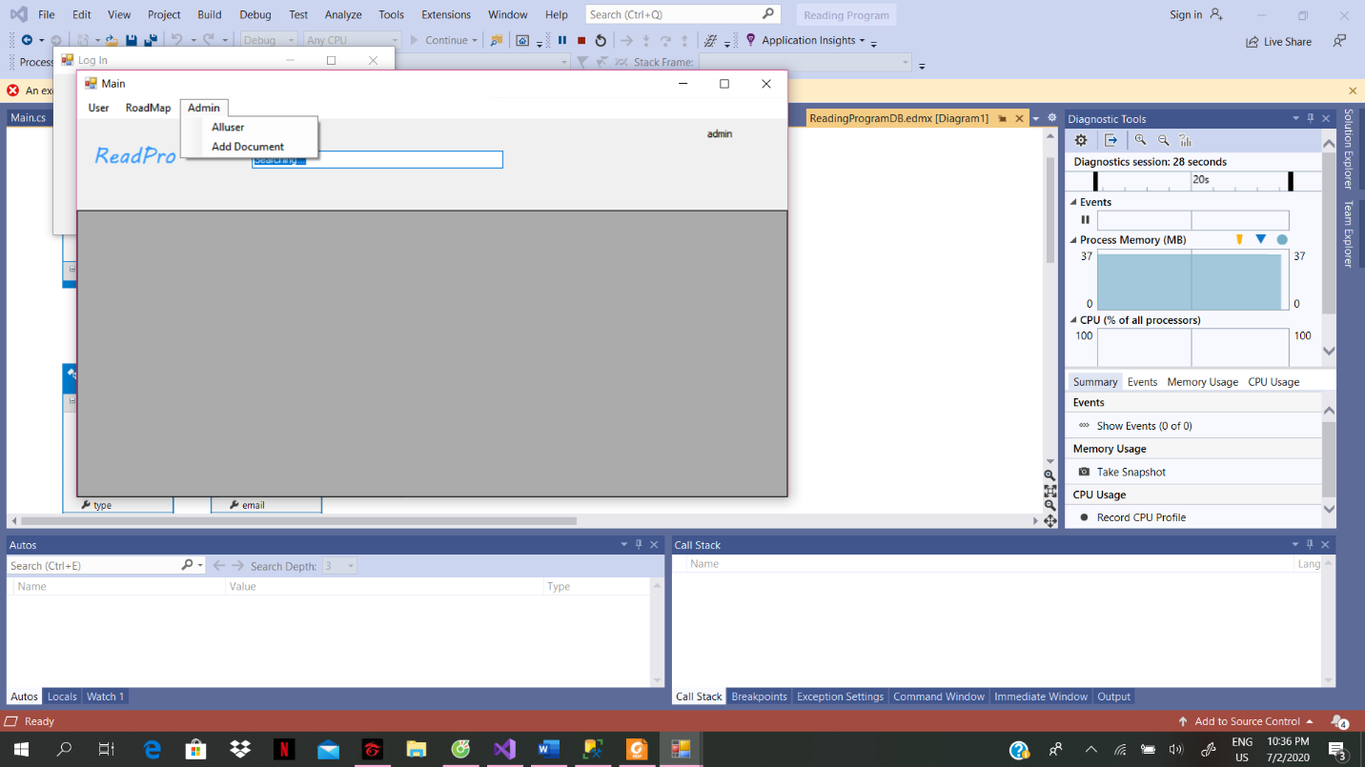Login with admin account, admin has a specific gui to show all user and add new document

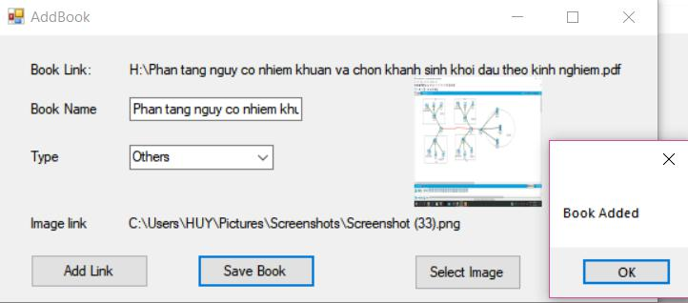

Add new book to list

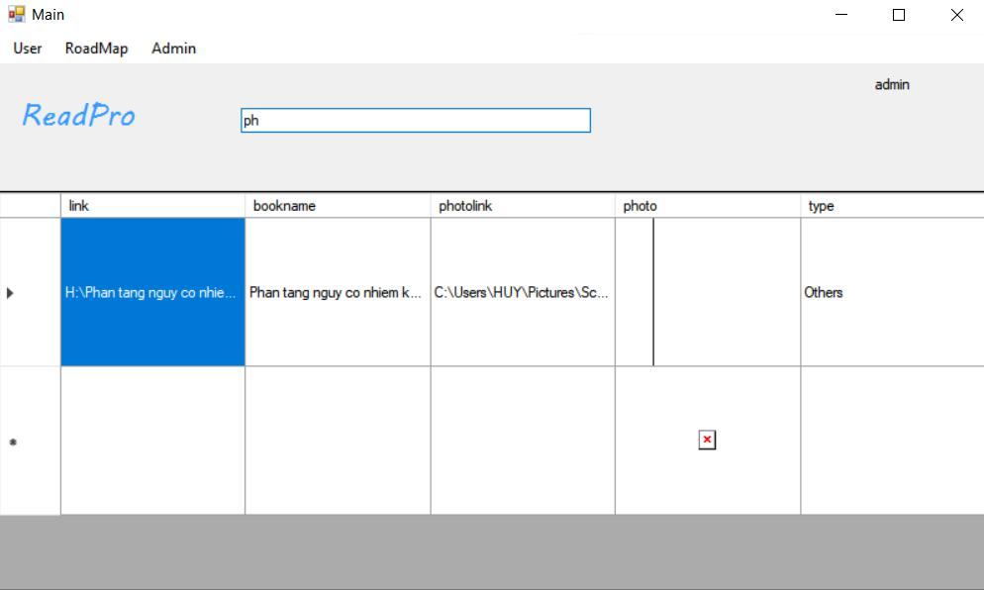

Search book in the search section

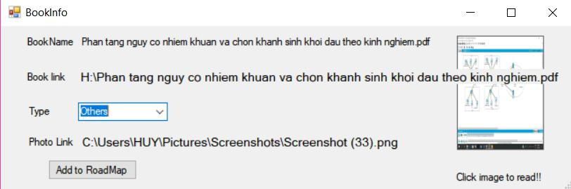

Show book information



Click on the image to read the book, also user can make some note on it, and view it by clicking view button, save by pressing save button, and delete by double clicking on that note ‘s gridview and press delete button to delete that note. Every time, save or delete note, user must press view button inorder to see new list of node adjustment they have just made.

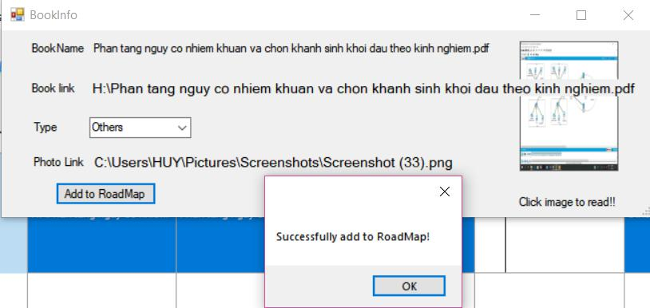

Add book to roadmap by user

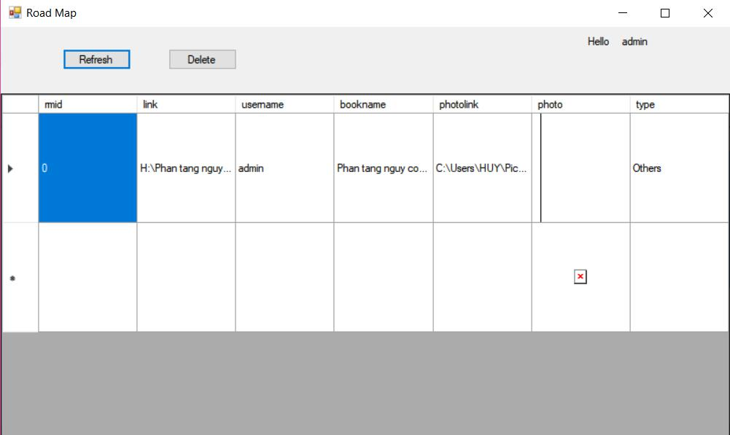

Road map of each user, user must press refresh button inorder to see the roadmap.Each user has their own roadmap. Right now the delete button is unusable because after deleting book out of roadmap, adding it back might cause error.

Chapter 5 : Development

* Improve the interface
* Personalize the program : Change avatar and more...
* Can open many type of ducument
* Can edit the content of document
* Develop the program similar to the Kindle of Amazon

***Reference:***

[1]Entity Framework (Microsoft) <https://docs.microsoft.com/en-us/ef/>

[2] C#: [Microsoft ADO.NET Entity Framework Step by Step-Microsoft Press (2013).pdf](https://fhqlms.hcmute.edu.vn/pluginfile.php/283638/mod_folder/content/0/Microsoft%20ADO.NET%20Entity%20Framework%20Step%20by%20Step-Microsoft%20Press%20%282013%29.pdf?forcedownload=1)

[3]C# 8.0 and NET.Core 3.0 – Modern Cross Platform Development Fourth Edition(2019).pdf

[4] Documentation windown forms’ on Website Microsoft <https://docs.microsoft.com/en-us/dotnet/framework/winforms/>